RESOLUTION NO.__________

RE: CERTIFICATE OF APPROPRIATENESS UNDER THE
PROVISIONS OF THE ACT OF THE PENNSYLVANIA
LEGISLATURE 1961, JUNE 13, P.L. 282 (53
SECTION 8004) AND BETHLEHEM ORDINANCE NO.
3952 AS AMENDED.

WHEREAS, it is proposed to install awnings at 702 E Fourth Street.

NOW, THEREFORE, BE IT RESOLVED by the Council of the City of Bethlehem that a Certificate of Appropriateness is hereby granted for the work.

Sponsored by: (s)

(s)

ADOPTED BY COUNCIL THIS DAY OF

(s)
President of Council

ATTEST:

(s)
City Clerk

HISTORIC CONSERVATION COMMISSION

CASE # 553 – It is proposed to install awnings at 702 E Fourth Street
OWNER/APPLICANT: John Gross / David Delos Santos

The Commission upon motion by Mr. Roeder seconded by Mr. Evans adopted the proposal that City Council issue a Certificate of Appropriateness for the proposed work described herein:
- The proposal to install awnings at 702 E Fourth Street was presented by David Delos Santos.
- Two shed style awnings in red Sunbrella fabric will be installed over the display windows on the north and west elevations. They will have a 24” projection and be mounted into mortar joints.
- The awnings will have open ends and no valance.
- A color sample of the awning fabric must be submitted to the Historic Officer for approval.
- The proposed motion was unanimously approved.

CU: cu
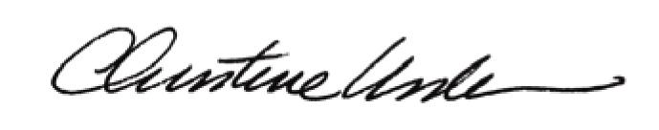

By:

Date of Meeting: June 15, 2015 Title: Historic Officer

